


This Trademark & Claims Policy, together with the Climate Neutral Standard and the Assurance Protocol form the core programme documents of the Climate Neutral Certification Programme. This Trademark & Claims Policy has been revised in 2022, in collaboration with a selection of stakeholders following the ISEAL Codes of Good Practice. Reason for this revision was to reflect on and institutionalise practises already adopted in reality since the programme went live in January 2021 and to integrate more rules where we have learned they are useful.
This new version of the Trademark & Claims Policy is published on and becomes effective from the 1st of May, 2022 (with a grace period of three (3) months where needed). The document is available in English, which should be considered as the official and binding version, and is publicly available for free from our website and printed in limited edition. For more information about the Climate Neutral Certification Program, please consult our website: www.climateneutralcertification.com/ or mail to: certification@climateneutralcertification.com.
Climate Neutral Group (CNG) wants to accelerate the transition to a net-zero carbon economy.
We help our clients to reduce their carbon emissions and their environmental impact, by offering
services: (1) we calculate your carbon footprint, (2) we advise you how to reduce your emissions,
4
we offer credible offsets for emissions that cannot be reduced (yet), and finally, (4) we offer a
(3)
practical and impactful certification program that allows certified clients to proudly use the

Climate Neutral Trademark. For more information, see:
n
http://www.climateneutralgroup.com/e
.

DISCLAIMER
©
Climate Neutral Group 2022. No part of this publication may be reproduced, stored in a retrieval system, or
transmitted in any form or by any means electronic, mechanical, photocopying, recording or otherwise without full attribution.
DOC ID:

CNG_TR_CL_VS1.2
DEVELOPED BY:

CNG - CERTIFICATION TEAM
APPROVED BY:

CNG - SALES & MARKETING DIRECTOR, ON BEHALF OF THE ADVISORY COMMITTEE
RELEASE DATE:

MAY
01
2022
IMPLEMENTATION DATE:

2022
MAY
01
EXPIRATION DATE:

CNG SHALL REVIEW THIS DOCUMENT AT LEAST ONCE EVERY FOUR YEARS,

BUT RESERVES THE RIGHT TO AMEND THIS DOCUMENT EARLIER.

Climate Neutral Certification Program
2022)
(
vs 1.2 - May
TRADEMARK & CLAIMS POLICY
www.climateneutralcertification.com
www.climateneutralgroup.com

a

CONTENTS
- Introduction .............................................................................................................................................4
- Rulebook ...................................................................................................................................................4
  - General provisions ......................................................................................................................................................4
  - Available Climate Neutral Certification Trademark ............................................................................................5
  - How to use the trademark and claims? ................................................................................................................5
  - How to use trademarks and claims off-pack? ...................................................................................................5
  - How to use trademarks and claims on-pack? ...................................................................................................6
  - How to use trademarks and claims ‘on-service’? ...............................................................................................6
  - What claims and trademark use is appropriate? .................................................................................................7
  - Is there an approval process preceding trademark and claims use? .............................................................8
  - When can the Climate Neutral trademark (and claims) be used? ..................................................................8
  - Available Climate Neutral Certification trademark formats and colours .........................................................9
  - What are the costs for trademark and claims use? ..........................................................................................10
  - When is trademark use and claims-making considered to be misleading? ...............................................10
  - When is the trademark and/or claims approval withdrawn? ......................................................................... 11
  - How to report misuse or misleading use of trademarks and claims? ......................................................... 11
  - Disclaimer .................................................................................................................................................................... 11

Introduction
This Trademark & Claims Policy complements the Climate Neutral Standard and the Assurance Protocol and is aligned with ISEAL’s Good Practice Guide on Sustainability Claims. It describes the different Climate Neutral Trademark options (further referred to as ‘trademarks’) as well as the rules regarding trademark use and claims-making. All (prospect/ certified) clients, further referred to as (prospect) Certificate Owners, or (prospect) ‘COs’, are expected to accurately follow the rules stipulated in this document, so that misuse or misleading use of the trademark is prevented, legitimate claims are made and the overall program’s integrity and credibility is protected.

Rulebook
1. General provisions
- ‘(Prospect) Certificate Owner (CO)’: refers to the CO’s legal entity that has been certified in the past or prospects wishing to become certified in the future. This entity is responsible for compliance with the Standard for the chosen certification scope. Upon a positive certification decision, this entity is owner of the certificate, may make claims about its compliance and may use the Climate Neutral Trademark.
- ‘End-user’: refers to a brand-owner or retailer (often the last link in the supply chain) that is licensed to sell the CO’s certified product or service to consumers, usually under a ‘brand-name’. Consumers are NOT considered to be an end-user. If an end-user is licensed to make claims about the CO’s compliance and endorsed to use the Climate Neutral Trademark, all rules stipulated in this document then apply also to the end-user.

(Prospect) COs, whether (intending to become) certified for their organisation, product(s) and/or service(s), always commit to:
- Adhere to this policy document to their best knowledge and capabilities.
- Intend to display the trademark, off-pack and/ or on-pack (if permitted), accompanied by a (short) text claim or explanation following the rules in the section hereunder, in order to be recognizable as a CO;
- Publish the information related to the CO’s certification status on the CO’s website (and website of the end-user, if applicable, see textbox 1);
- Agree that CNG may publish the same information related to the CO’s certification status on the CNG certification website (“Check-a-label"), and may also publish the brand-name or brand-logo (or other identification) of the certified product(s) or service(s);
- Not share the trademark with other organisations, except for organisations assigned by the CO, such as manufacturers or design companies of the packaging material for the certified product, or end-users of the certified product or service;
- Obtain approval from CNG prior to external communication about the Climate Neutral Certification Program and/or prior to making claims and/or using the trademark, following the rules stipulated in section 8.
IMPORTANT NOTES REGARDING CERTIFICATION OF A PRODUCT:

In the event the (prospect) CO and its end-user(s) (i.e. the brand-owner or retailer) have agreed that trademark use and claims making is handled by the end-user, the end-user may contact CNG for trademark approval and claims use instead (provided the CO is included in email exchange). In that case, all rules stipulated in this document apply to the end-user, nevertheless the final liability and responsibility for accurately following these rules remain with the (prospect) CO. It is the responsibility of the (prospect) CO to seek consent from end-users to display the brand-name or brand logo.

To facilitate control for the (prospect) CO, CB and CNG, the (prospect) CO needs to have a contract with its end-user(s) in place that stipulates the legal responsibilities between both parties throughout the approval process and also in case of termination of certification (see section 13). In addition, all end-users are requested to sign a license agreement with CNG (see Assurance Protocol, section 2.3).

In the case of end-users, on-pack claims shall make reference to the website of the end-user (and not of the CO), so that consumers buying the certified products can directly go to the end-users website for more information.

Also, the (prospect) CO maintains a registry of certified products per end user. If a new end user and/ or new brand-name is added outside the certification cycle (see section 8, step 6), the (prospect) CO shall inform CNG latest three (3) weeks prior to sending packaging designs for printing.
Textbox 1: Rules related to end-users

- Available Climate Neutral Certification Trademark

For all certification scopes (i.e., organisation, product, or service), one trademark (in English) is available. Since the trademark is suitable to all scopes, it is obliged to indicate the certification scope in the accompanying text claim, which can be made in any language. For on-pack product certification only, other versions as e.g., black-and-white, and transparent are allowed, see section 10. To obtain the trademarks in diverse formats kindly contact: communication@climateneutralgroup.com.
Figure 1: The formally registered Climate Neutral Certified trademark

- How to use the trademark and claims?
Certification Scope | Off-pack | On-pack | ‘On-service’
Organisation | x
Product | x | x
Service | x |  | x
Table 1: Use of trademark and claims
- For certification of the organisation: Trademarks and (text) claims shall be made generally and in relation to the organisation, and clearly refer to the GHG emission sources covered under the agreed boundaries of the organisation itself (see criterion 2.1 and 2.2 of the Standard). Also, claims shall be made in such a way that they cannot be associated with a certain product or service delivered by the organisation or products and services in general (see also section 4).
- For certification of a product: Trademarks and (text) claims shall be made (i.e. printed) on the certified product(s) itself, following the rules in section 5, and not on any other (non-certified) products. Claims and trademark use may also be off-pack, following the rules in section 4. All claims shall clearly refer to the GHG emission sources covered under the agreed boundaries of the certified product e.g. from ‘cradle-to-gate,’ ‘cradle-to-shelf’ or from ‘cradle-to-grave’ (see criterion 2.1 and 2.2 of the Standard).
- For certification of a service: Trademarks and (text) claims shall be made in such a way that they can be directly associated with the certified service, following the rules in section 6 (and section 4, if applicable). If the (prospect) CO requires tools or equipment in order to provide or execute the service, such as transport vehicles or machinery, trademarks and claims may be printed thereon. All claims shall clearly refer to the GHG emission sources covered under the agreed boundaries of the certified service (see criterion 2.1 and 2.2 of the Standard).
- How to use trademarks and claims off-pack?
Trademarks and claims may be used off-pack, such as in general company brochures or on other press-work, on the CO’s website, in advertisements, in social media, in company reports (e.g. annual reports), on company vehicles or fleet (provided the CO does not provide transport-related services), etc. For certification of a product or service, off-pack use is allowed, provided that the name or another unique identifier of the certified product(s) or service(s) is clearly mentioned.

- How to use trademarks and claims on-pack?
Trademarks and claims may be used on-pack, as illustrated below in figure 2.
- In the case of only outer-packaging (e.g. if the product still needs to be repacked in units for onwards selling or consumption), trademarks and claims may be printed on the outer-packaging material.
- If no packaging is used at all, trademarks and claims may be printed on or attached to the product itself.
- If limited space is available on the product or its packaging, only the trademark with a QR code or a website link (directing to the CO’s or end-user’s website) suffices.
- If a product consists of many ingredients, and an exception is granted that only a significant part of these ingredients has been included in the boundaries (see criterion 3.1 of the Standard), this shall then be clearly communicated through an explanatory text accompanying the trademark.

NOTE: If the packaging material itself is certified (and not the content therein, i.e. the product itself), the trademark may be printed on the packaging material, but the claim shall clearly describe that it is the packaging that is certified (and not the content). Ideally, the trademark shall be printed on a less visible place, e.g. on the inside, back-of-pack or side-of-pack.
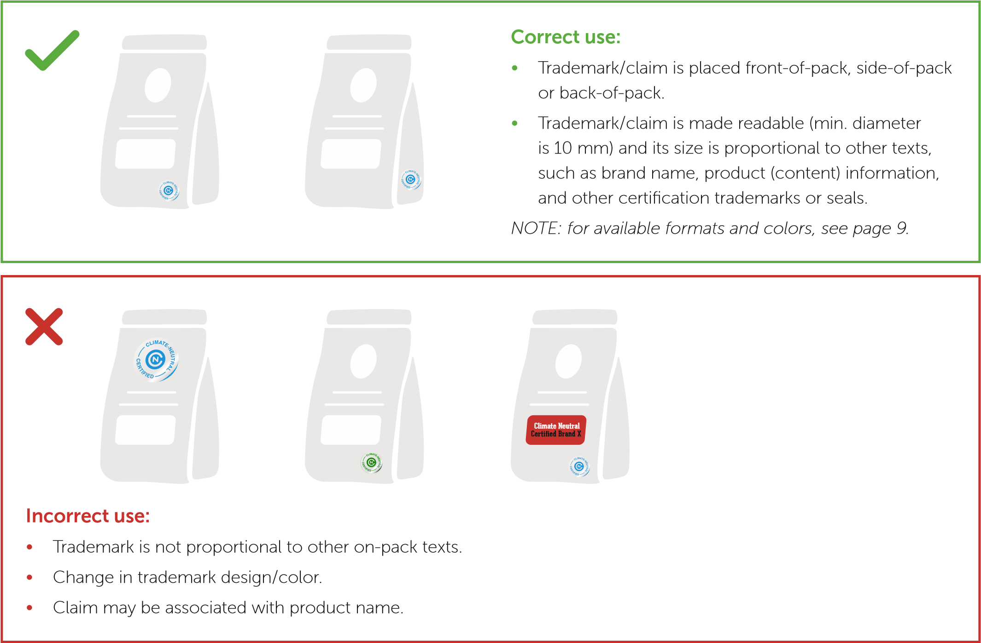
Figure 2: Examples of correct and incorrect use of trademark and claims
- How to use trademarks and claims ‘on-service’?
Trademarks and claims may be used ‘on-service’, meaning that the claim or trademark may be printed on tools, equipment or another tangible item that is used in order to provide or execute the service, such as transport vehicles, machinery, equipment, etc.

- What claims and trademark use is appropriate?
- Trademark use, whether on-pack or off-pack, is accompanied by a (short) explanation (or claim) with reference to the CNG certification website (www.climateneutralcertification.com). Ideally, claims or explanatory texts are as brief but as complete as possible and shall be clear and transparent. Considered as the shortest possible explanation (claim), e.g. in the case packaging material is too small for long texts), is a QR Code or a URL to or the CO’s or end-user’s website where more information is available.
- All explanations or claims shall make reference to the certification scope (organisation, product, service) and the footprint’s organisational and operational boundaries (i.e. overclaiming is not permitted). If certain GHG emission sources are excluded, or exceptions are made, this is clearly communicated in the claim. If the CO makes use of the ‘cradle-to-gate’ or ‘cradle-to-shelf’ option in the case of ‘certification of a product’, or leaves out the use and disposal phase in the case of ‘certification of a service’ (see criterion 2.2. of the Standard), this shall be clearly explained in the claim. Section 11 gives two examples of misleading claims.

- Combining the trademark with other sustainability logos, seals or trademarks is permitted, as long as these do not make an explicit climate and/or CO₂ claim.
- The trademark may not be placed or used in such a way that the impression can be created that the trademark belongs to a brand or organisation other than Climate Neutral Group.
- CNG reserves the right to impose certain conditions to claims-making and/ or the use of the trademark, e.g. for COs that operate in an ethically sensitive sector.
Please note:
For claims containing the word “CO₂”, the subscript functionality shall be used in on- and offline communications: CO₂ > 2 in subscript and in html <sub>2</sub>.

Textbox 2: Wording of CO2

Examples:
Certification of a product:
“The total CO2 emissions of these bananas have been calculated from plantation to (retailer) shelf. We endeavour to reduce these emissions year after year and are proud of the 10% reduction we have already achieved since 2018. What we cannot reduce yet, we compensate through VCS certified climate smart projects. For more information, see: CO’s company website.”
Certification of the organisation:
“Our organisation is certified against the Climate Neutral Standard: the appreciation that our efforts are actually significant when dealing with climate issues. Our business operations have been tested against strict criteria. We reduce our CO2 emissions as required by the Paris Agreement and the CNG Standard with at least 3% annually, and we compensate all CO2 emissions that we cannot (yet) reduce with a Gold Standard certified cookstove project in Kenia. We are therefore proudly using the trademark for our climate-neutral organisation. For more information, see: www.climateneutralcertification.com.“
Certification of a set of products:
“We, Company X, have worked with our suppliers to bring emissions down in their production processes. We have invested in a new spraying technique which has reduced CO2 emissions with 5% per kg coffee produced. We continue to make serious efforts for further CO2 reduction in our supply chains, and we compensate all remaining emissions that we cannot (yet) reduce with Gold Standard certified climate smart coffee projects in Vietnam. We can therefore legitimately say our coffee products are ‘climate neutral’. For more information, see: www.climateneutralcertification.com and end-user website.”
Certification of a service:
“We have made serious investments in our fleet, and we are now excited to announce that since date X our transport service leaves hardly any carbon footprint. All our trucks are now electric and use green energy generated by windmills in the Flevopolders. Our efforts have been audited by an independent verifier against the Climate Neutral Standard, and we are now allowed to display the Climate Neutral trademark for our transport service. For more information, see: www.climateneutralcertification.com.”

Textbox 3: Examples of correct claims
- Is there an approval process preceding trademark and claims use?
Trademarks and claims approvals need to be in place (for all on-pack and off-pack use) prior to the audit. Subject to approval are all publicly used designs and texts, whether used by the CO or the end-user, that A) make reference to the Climate Neutral Certification Programme, B) can be associated with the term ‘climate neutrality’, and/or C) make use of the Climate Neutral Trademark.
(Prospect) COs shall submit their proposals as to how they wish to make claims and use the trademark (e.g. draft website texts or packaging designs) to CNG. When deemed satisfactory, CNG will issue a tentative approval (design approval). In the meantime, (prospect) COs may start printing packaging material or brochures, etc, but this at the risk of the (prospect) CO. However, only once the CB has issued a positive certification decision, the tentative approval becomes a definite approval and these design concepts (as approved by CNG) may be brought to the public domain, e.g. published or distributed.
In detail, the following procedure applies:
1 | Prior to the audit, the (prospect) CO needs to have all tentative trademark and claims approvals in place in accordance with criterion 5.2. of the Standard.  As such, latest three (3) weeks prior to the audit date and latest three (3) weeks prior to the deadlines mentioned under A, B and C (see below), the (prospect) CO submits an approval request for all trademarks and/ or claims use to CNG by mail to: communication@climateneutralgroup.com. If the end-user requests approval, the (prospect) CO shall be included on the email exchange.  - For on-pack use: Always obtain design approval for packaging material, prior to printing of packaging material (or of the certified product, if the trademark or claim is printed thereon).  - For off-pack use: Always obtain design approval for publication on the CO’s website (e.g. sustainability page), press releases or news item, prior to public launch;  - For ‘on-service’ use: Always obtain design approval, prior to public use, whether the trademark and/or claim is made on-pack or off-pack.  NOTE: Earlier tentative approval requests may be submitted e.g. if the (prospect) CO or end-user already wishes to already start printing packaging material or brochures, however this is at the risk of the (prospect) CO and conditional to a positive certification decision.  NOTE: CNG does not share marketing material nor trademark logos if the contract between CNG and (prospect) CO (and the license agreements with end-users) has not been signed yet (see Assurance Protocol, section 2.3).
2 | CNG responds to the (prospect) CO’s approval request within one (1) week by mail with either a tentative approval confirmation, or required adjustments to be made.
3 | If adjustments are required, the (prospect) CO resubmits a revised approval request, and CNG responds again within one (1) week.
4 | During the audit, the (prospect) CO demonstrates CNG’s tentative approval mail to the CB.  NOTE: the (prospect) CO is required to submit all audit documentation, including the trademark and claims approvals from CNG latest two (2) weeks prior to the audit to the CB (see Assurance Protocol, section 2.3). Failure to submit the approvals in due time may lead to a non-conformity.
5 | After a positive certification decision (see section 9), the CO may make claims and/or use trademarks as agreed with and tentatively approved by CNG. That means that the tentative approval becomes a definite approval, and that e.g. the draft texts may now be made public on the CO’s company website, the printed material may be distributed, and the packaging material may be used.
6 | If after the audit (and the positive certification decision) the CO wishes to make other off-pack claims and trademark use (e.g. a new company brochure is launched for months later), this is permitted and does not require separate approvals, provided this in accordance with previously issued off-pack approvals.  If after the audit (and a positive certification decision) the CO wishes to launch more products as certified and thus make on-pack claims and use the trademark for these new products, this is permitted and does not require new approvals, provided A) these new products belong to a product category that is already certified (see Standard, criterion 2.1 and Assurance Protocol, textbox 2, point 3), B) the claim is the same as the already approved one, and C) CNG is informed, so that these products can be added to the CNG certification website (“Check-a-label").  For press releases, approval from CNG shall always be obtained.  In case of doubt, CNG always recommends to contact communication@climateneutralgroup.com, to prevent a situation of illegitimate claiming and all consequences thereof.
Table 2: Trademark and claims approval process
NOTE: Deviation from the above steps is only permitted after written approval from CNG. Failure to submit the approval requests in due time (i.e. to obtain the required approvals prior to the audit and prior to public use or display), may lead to certification delays, suspension or non-certification.

9. When can the Climate Neutral Trademark (and claims) be used?
For first year of certification:
- COs that have received a positive certification decision for their first audit may start using the Climate Neutral Trademark and may start making claims. The certification decision is communicated by the CB to the CO in the form of an audit report or a certificate. Only when the certification decision is positive, the CO may make public claims and use the trademark publicly (see Assurance Protocol, section 2.3).

For subsequent years of certification:
- COs that are found compliant with the Standard after a consecutive audit resulting in a positive certification decision may continue using the Climate Neutral Trademark for another validity period (see Assurance Protocol, section 2.3).

- Available Climate Neutral Certification trademark formats and colours
The Climate Neutral Certification trademark is available in blue and white for colour applications, which is the preferred use. Black and white for grayscale applications are available also. Kindly adhere to the colour schemes (see table 3) and available trademark formats (see table 4 and figure 3).

For obtaining the CNG trademarks and other useful marketing material, kindly contact: communication@climateneutralgroup.com.


For Print

CNG Blue

CNG Dark Blue

CMYK

/ 30 / 0 /
90
0

/ 80 /30 /
20
100

PMS (Pantone)
Coated

PMS 299 C

PMS (Pantone)

Uncoated

PMS 299 U

For Screen and Web (RGB)

CNG Blue

CNG Dark Blue

RGB

0
/ 135 /
204

19
/ 58 /
104

Table 3: Colour schemes
Climate Neutral Certification trademark - Product - Organisation - Service
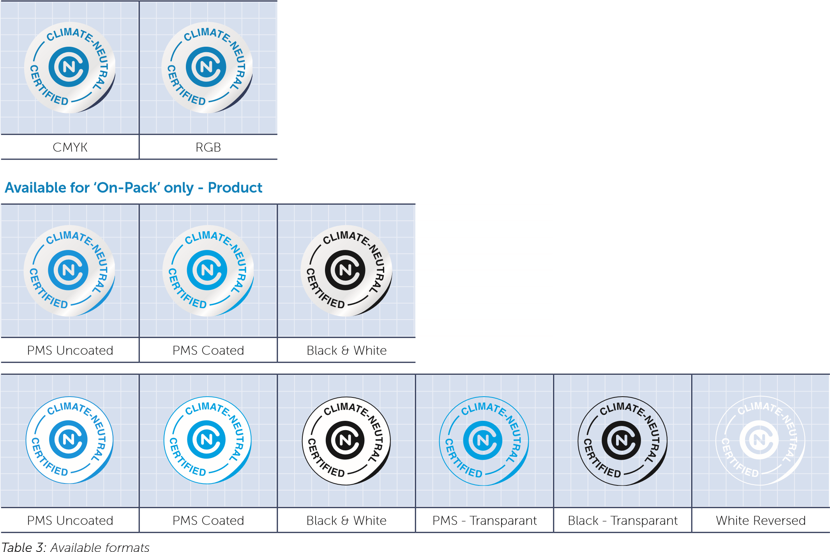

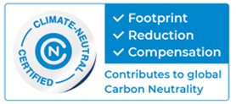
IMPORTANT: (Inter)national regulation and legislation increasingly require more extensive claims, e.g. in France, the Netherlands, Germany, Denmark and Sweden. Such legislation may require a.o. the specification of reduction commitments (e.g. the CO’s annual reduction target or reductions achieved compared to the baseline), as well as more details on the offset project (e.g. the name and country of the offset project and under which scheme the project was certified). The (prospect) CO is responsible for understanding and adhering to such (inter)national regulation and legislation always, and CNG cannot be hold accountable. To give (prospect) COs the choice to make use of a more nuanced claim, CNG allows for two alternative trademark options, as illustrated in figure 3. These can be obtained by contacting: communication@climateneutralgroup.com . Note that the text in the alternative trademarks does not substitute text claims.
Logo 2 still to be inserted
Figure 3: Alternative versions of the Trademark

- What are the costs for trademark and claims use?
The programme fee (excl. VAT) entitles COs to use the Climate Neutral Trademark and to make claims about the CO’s compliance with the Standard. The programme fee structure is defined as follows:
Certification of the organisation |  | Certification of a product or | service
Revenue (€) | Annual fee in € | Tonnage (CO₂) | Annual fee in €/ton CO₂
< 1 mln | 250 | 0 – 1,000 | 1.00
1-5 mln | 500 | 1,000 – 5,000 | 0.75
5-10 mln | 750 | 5,000 – 25,000 | 0.50
10-50 mln | 1,000 | 25,000 – 50,000 | 0.25
50-100 mln | 1,250 | 50,000 – 100,000 | 0.20
100-250 mln | 1,500 | >100,000 | 0.15
250-500 mln | 2,000
500 mln-1 mld | 3,000
> 1 mld | On request
Table 4: Programme fee
The programme fee for the certification of a product and/or service is based on the T CO2 volume of the gross footprint of all certified products/ services combined. The programme fee for the certification of an organisation is currently based on the CO’s total revenue, but most likely this will be changed also into T CO2 volume, once the Standard is being revised (envisioned for 2023).
If a CO is certified for all its products or services (i.e. its entire product or service portfolio), the CO automatically becomes certified for its organisation (because all scope 1, 2, and non-attributable scope 3 emissions shall be included in the footprint anyways). In this case, the CO only pays the programme fee for its products or services, and does not pay the organisation programme fee. If a CO is only certified for some products or services, plus certified for the organisation, the CO receives a discount on the organisation programme fee, which is equal to the share of the certified climate-neutral products or services, compared to the total product or service portfolio of the CO. If the CO is only certified for some products or services, the CO pays the programme fee of its products or services, corresponding with the total footprint of the certified product(s) or service(s).
The programme fee shall be charged over the time the CO is certified and is entitled to make claims. The moment of payment is aligned with the offset payment cycle (see Assurance Protocol, section 2.3, step 1). That means the following options are available, to be agreed between the (prospect) CO and CNG:
  - The programme fee is charged upfront annually in the form of a lump sum, based on the CO’s previous year’s revenue (in case of certification of an organisation) or CO’s estimated footprint volume (in case of product/ service certification).
NOTE: For first year of certification: the program fee is proportionally calculated for the timeframe that the CO is certified and may make claims. Example: if the CO receives a positive certification decision on the 1st of October 2022, then the program fee for 2022 to be paid is 3/12 * annual fee.

  - The programme fee is charged retro-actively on a quarterly basis, over the sales of certified products in the past three (3) months (only possible in the case of certification of a product or service).

At the time the program fee invoice is sent, the definite footprint (ascertained after the audit) nor the date a positive certification decision is issued, is unknown, which could imply too much/ too little has been paid by the CO. L If so, CNG will settle the fee after the audit and issue an additional invoice or credit note.

- When is trademark use and claims-making considered to be misleading?
The use of claims and trademarks should correspond with the certification scope and the operational and organisational boundaries (see section 3), and may not give room to multiple interpretations.

Example 1 of misleading claims
Company X provides a range of online services for customers to store their data in the cloud. This data is stored on servers that consume a lot of electricity. These servers are owned by sister-company Y. Company X is certified for the organisation, and the servers’ electricity use is excluded from the scope. Company X has placed the Climate Neutral Trademark on the webpage where customers can actually upload their data, and proudly announces to be “the first data storage centre that is climate neutral”.
Why is this misleading?
The trademark may not be placed in such a way that it could be interpreted differently. In this example, and because the Trademark is directly placed on the service itself, the claim may suggest that the data uploading service is climate neutral, which is not the case.
What is then possible?
Company X may report about their climate-neutral organisation in its annual report or on a more general webpage, e.g. the company profile page. The claim should then clearly describe that the organisation is climate-neutral and not the service.

Example 2 of misleading claims
Company Y produces plastic products from recycled material. Company Y is certified for the organisation and has placed the Climate Neutral Trademark on its webpage with the following claim: “we produce our entire range of plastic products CO2 neutrally”.
Why is this misleading?
The claim is ambiguous in the sense that it could potentially be interpreted as if these products are climate neutral.
What is then possible?
To make sure the claim cannot be misinterpreted, better wording would be: “our organisation and our production facility are climate neutral”.
Textbox 3: Examples of misleading claims
13. When is the trademark and/or claims approval withdrawn?
The right to use the trademark and/or to make claims can be withdrawn by CNG and/or CB in the following instances, see also Assurance Protocol, section 2.8:
- Non-certification or suspension: the CO is not compliant (anymore) with the Standard, or a negative certification decision has been issued;
- Voluntary termination: the CO ends the programme contract (with CNG) or the audit contract (with CB);
- Payment failure: CNG or CB ends the programme contract or audit contract and the CB issues a suspension/ non-certification, if CO does not pay respective fees in due time;
- Fraud:
- the CO has deliberately committed fraud, made false promises or misused the claims or trademarks and the CB issues a suspension/ non-certification.

- In the case of a non-certification, suspension or voluntary termination of the certificate by the CO, the ‘No Use of Trademark and Claims Declaration Form’ is signed by both the CO, CNG and CB, in which agreements regarding claims removals and other conditions are stipulated (see below). This form is available upon request from: certification@climateneutralgroup.com.

- For the time the CO was not certified (either because of non-certification, suspension or voluntary termination by the CO) the non-certified/ suspended CO is not allowed to promote itself or its product/service as compliant with the Standard, may not make claims nor use the trademark.

- If products or packaging material are still available with on-pack claims, under certain conditions these can be finished till an agreed deadline. As a minimum, remaining products and packaging material at factory level (manufacturing site) are re-labelled with stickers covering the trademark and claims.

- The non-certified/ suspended CO shall actively inform its clients and stakeholders in writing that they are not certified (anymore).

- The non-certified/ suspended CO is still obliged to pay outstanding audit fees, and shall still pay offsets and the CNG programme fee for the time claims are still made.

- Other potential consequences e.g. in regard to claims removal, product recalls, use of remaining packaging material, penalty fees, next opportunity for re-certification, etc. will always be discussed between CB, CNG and CO and may overrule the above.

- Failure by the non-certified/ suspended CO to abide to the agreements stipulated in the signed ‘No Use of Trademark and Claims Declaration Form’, or any other forms of misuse and/ or misleading use may -in the worst-case scenario- lead to legal intervention by CNG and/ or the CB.

- How to report misuse or misleading use of trademarks and claims?
In case of misuse or misleading use noted within your own organisation, by other (prospect) COs, or by other (non-certified) parties, please contact CNG immediately at communication@climateneutralgroup.com or submit a grievance or complaint following CNG’s Complaints Procedure.
- Disclaimer
Climate Neutral Group reserves the right to amend this Trademark & Claims Policy (including the Programme Fee) at any time, following the ISEAL Codes of Good Practice. If changes occur, a grace period will apply so that COs will receive sufficient time to implement these changes.

Climate Neutral Group – Head office
Arthur van Schendelstraat 650
3511
MJ Utrecht
The Netherlands
E
certification@climateneutralgroup.com
| I
climateneutralcertification.com

T +31 30 232 6175 | E
i
nfo@climateneutralgroup.com
| I
climateneutralgroup.com
Climate Neutral Group

– South Africa
Workshop 17, Kloof Street
Gardens
Cape Town, 8005
South Africa
4
, The Firs, Biermann Avenue
Rosebank
Johannesburg, 2196
South Africa
T 021 202 6770 | E
i
nfo@climateneutralgroup.co.za
| I
climateneutralgroup.co.z
a

Additional guidelines can be found in the ISEAL’s Good Practice Guide on Sustainability Claims.
Use of the trademark and claims-making is strongly advised, but not mandatory.
E.g. product-name, product-logo, service-name, service-logo.
For existing COs, license agreements will be signed with end-users upon renewal of the CO’s contract with CNG. For new (prospect) COs, this applies from the 1st of May, 2022 onwards.
Otherwise, the trademark or claim may suggest that the service is certified.
The website of the CO or the end-user should then refer to the CNG certification website.
With the exception of reoccurring approval requests as indicated under step 6.
Gross footprint is the total footprint before any offsets, insetting, RECs or GoOs have been purchased.
If offsets are purchased with CNG. If offsets are not purchased from CNG, the programme fee is charged upfront in the form of a lump sum (option 1).
If desired to deviate from these two options, kindly contact CNG’s Carbon Advisor.

